BMI Calculator Project Part 1 Project Outputs

REST API

BMI REST MyBMI Output:

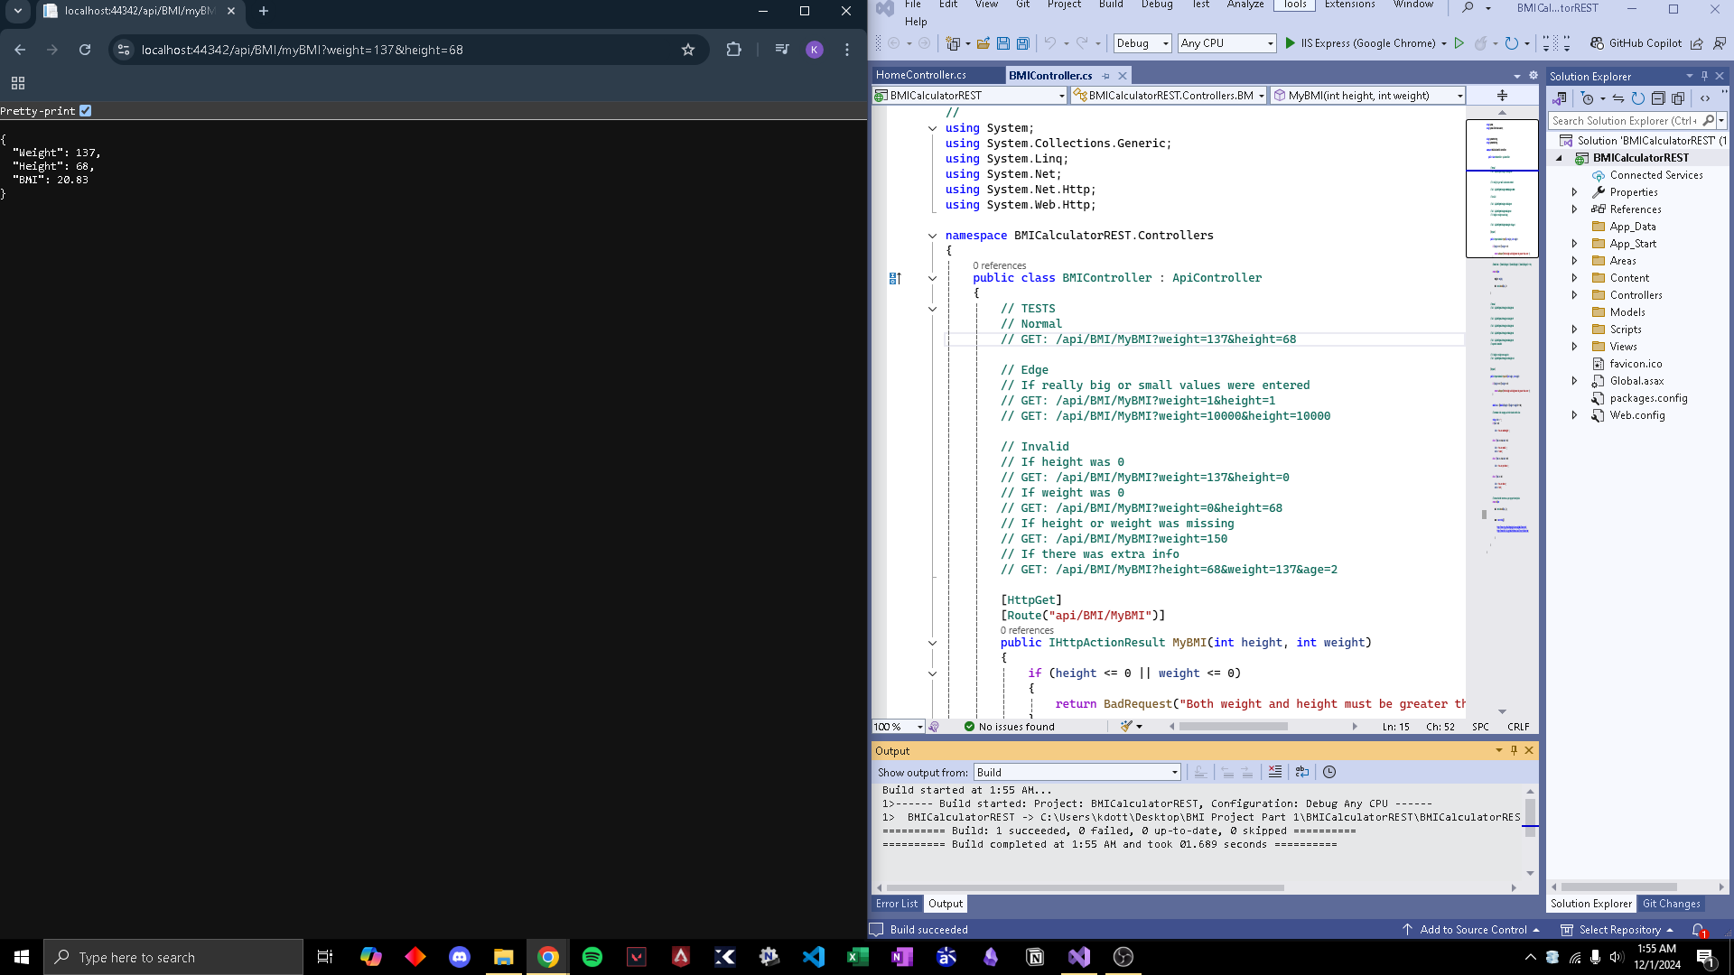

BMI REST MyHealth Output:

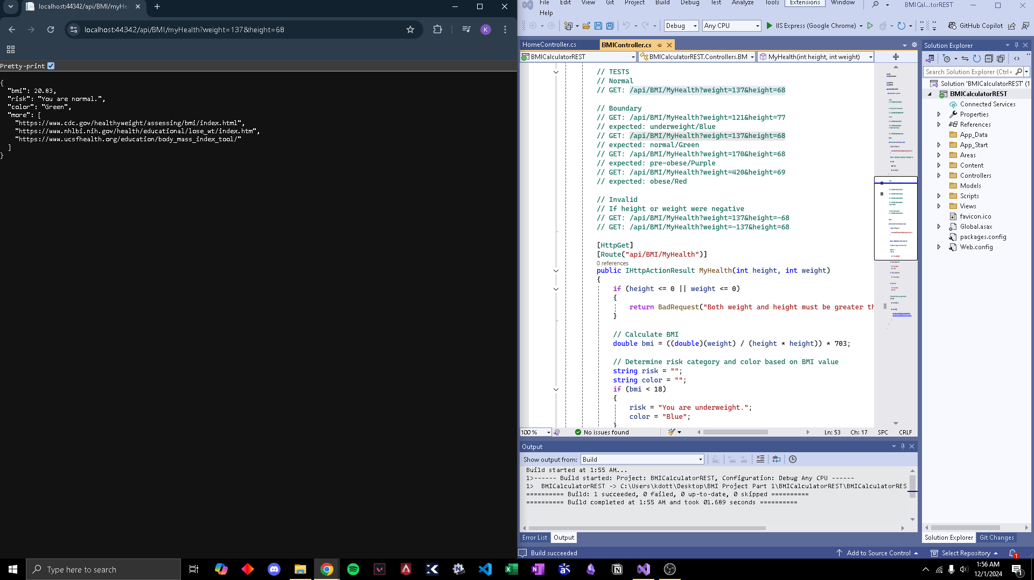

SOAP API
BMI SOAP MyBMI+MyHealth:
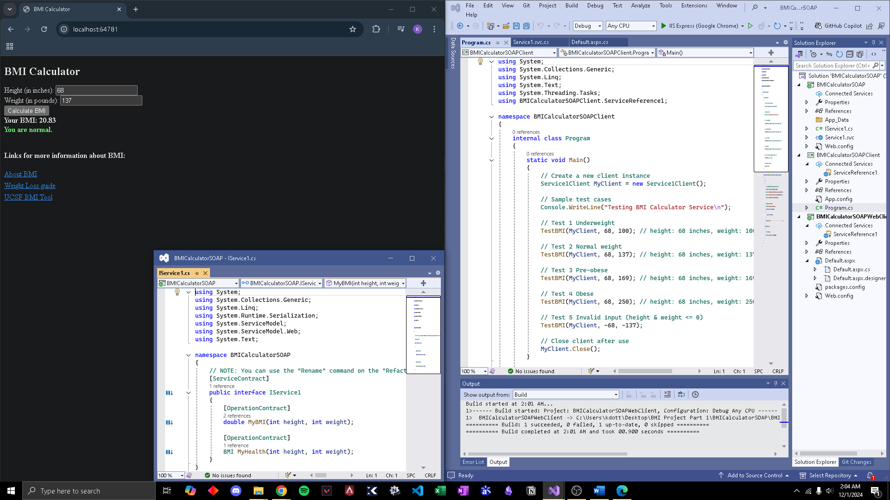
BMI SOAP API Web Client:
